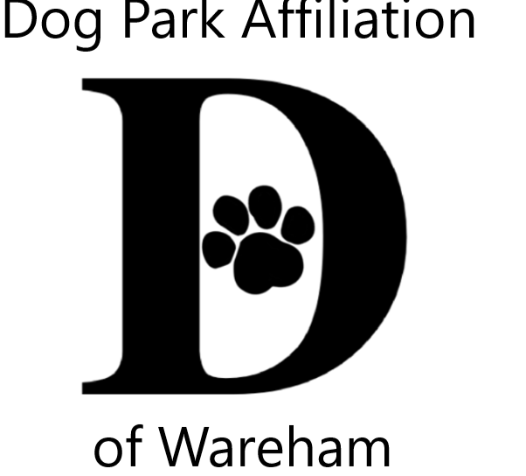 DPAW’s 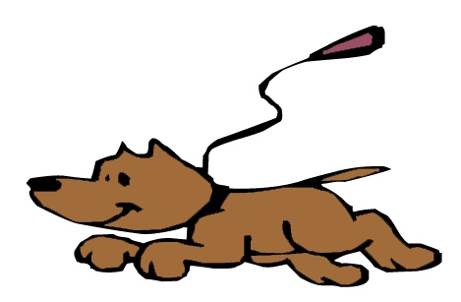Unleash the PAWsibilities
Area Youth Art & Literary Contests

2022 Themes
All creatures great & small
OR
Wareham Dog Park opening PAWty

Jurors from art & literary fields for 3 age groups
Ages; 5-8 9-12 13-16

Visual Art
2 dimensional (flat), any media/style,mixed media, no larger than 9x12
Literary
poetry, short story, lyrics, letter, descriptive, essay limited to one page

ALL contestants entered into a prize pool raffle
Enter BOTH VISUAL & LITERARY CONTESTS to increase your chances!
Winners also receive trophies

More contest info, tips & registration forms
www.warehamdogpark.org

Submissions accepted from July 6th thru August 10th

Submission sites
Wareham Free Library Gleason Family YMCA
Onset Bay Association Wareham TD Bank
Submissions become property of DPAW

Family celebration at Gleason Family YMCA August 26th
Late Summer Gallery of all entries @ Wareham Main St Post Office
;

Questions & contest info sammorrison@comcast.net

Sponsored by Dog Park Affiliation of Wareham (DPAW)

